## INTRODUCTION

### PROJECT OVERVIEW

The incidence of overweight and obesity has increased signiﬁcantly in most countries in recent decades. Excess weight is associated with an increased incidence of many chronic diseases, including vascular disease, respiratory disease, osteoarthritis, some cancer, type 2 diabetes, and premature death. There is consistent evidence that an in- creased BMI is associated with higher health costs, and these costs are expected to increase as obesity. Modelling uses machine-learning methods, in which the machine learns from the data and uses it to forecast new data. This study focused on ﬁne linear re- gression models, which conducted a complete comparison of penalty regression with linear regression in forecasting overall health costs, which was not reported in the pre- viously published literature. The major focus of this study is to estimate the health costs incurred due to obesity in the population.

### PURPOSE

The purpose of the above project on the estimation and prediction of hospitalization and medical care costs is to develop a comprehensive framework that accurately estimates and predicts the costs associated with hospitalization and medical care. By utilizing advanced data analytics techniques and machine learning algorithms, the project aims to provide valuable insights for healthcare providers, insurance companies, and policymakers. The primary objective is to optimize financial resources and staffing levels for healthcare providers, enabling them to efficiently manage their budgets and deliver quality patient care. Insurance companies can benefit from the project by developing fair pricing strategies and coverage plans, ensuring affordability for policyholders. Policymakers can utilize the project's findings to make informed decisions on resource allocation and healthcare policies, ensuring efficient and effective use of available resources. Ultimately, the project aims to enhance healthcare economics by improving cost management, promoting accessibility and affordability of healthcare services, and ultimately improving patient outcomes through evidence-based decision-making and cost-effective practices.

## IDEATION AND PROPOSED SOLUTION

#### Problem Statement Definition

Create a problem statement to understand your customer's point of view. The Customer Problem Statement template helps you focus on what matters to create experiences people will love.

A well-articulated customer problem statement allows you and your team to find the ideal solution for the challenges your customers face. Throughout the process, you’ll also be able to empathize with your customers, which helps you better understand how they perceive your product or service.



#### Empathy Map Canvas

The empathy map canvas is a tool that helps project teams gain a deeper understanding of the users or stakeholders involved in the project. In the context of the breast cancer detection project, the empathy map canvas can be used to develop empathy towards the healthcare professionals who will be using the system and the patients who will benefit from early detection.

By completing the empathy map canvas, the project team gains valuable insights into the perspectives, needs, and expectations of the healthcare professionals and patients involved in breast cancer detection. This understanding helps inform the design, development, and implementation of the system, ensuring that it meets the users' requirements, aligns with their workflow, and delivers a positive impact on breast cancer detection and patient care.

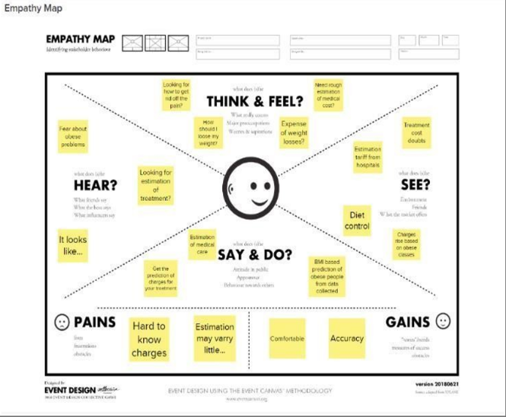

#### Ideation and Brainstorming

Ideation and brainstorming for the above project involve generating and exploring creative ideas to enhance breast cancer detection using deep learning methods. The goal is to foster innovation, identify potential solutions, and uncover new possibilities for improving early detection and diagnosis.

During ideation, the project team can engage in various brainstorming techniques, such as divergent thinking, to generate a wide range of ideas. They can explore different aspects of the project, including data collection, preprocessing techniques, model selection, user interface design, and performance evaluation.

**Step-1: Team Gathering, Collaboration and Select the Problem Statement**

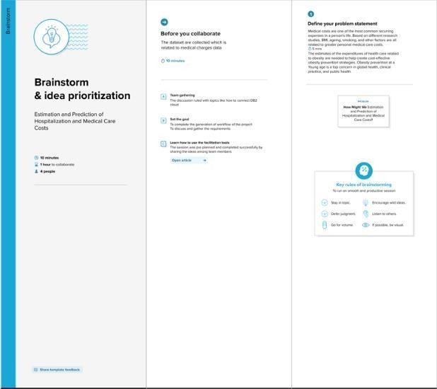

**Step-2: Brainstorm, Idea Listing and Grouping**

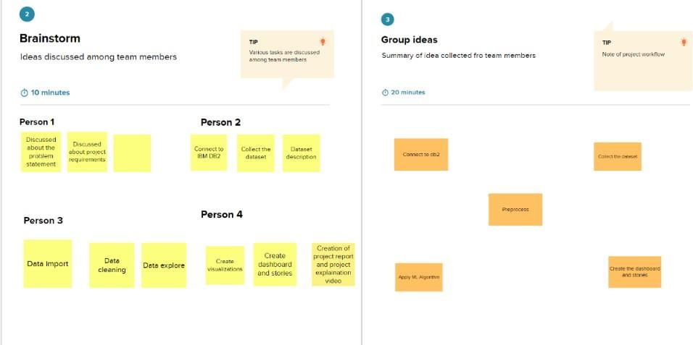

**Step-3: Idea Prioritization**

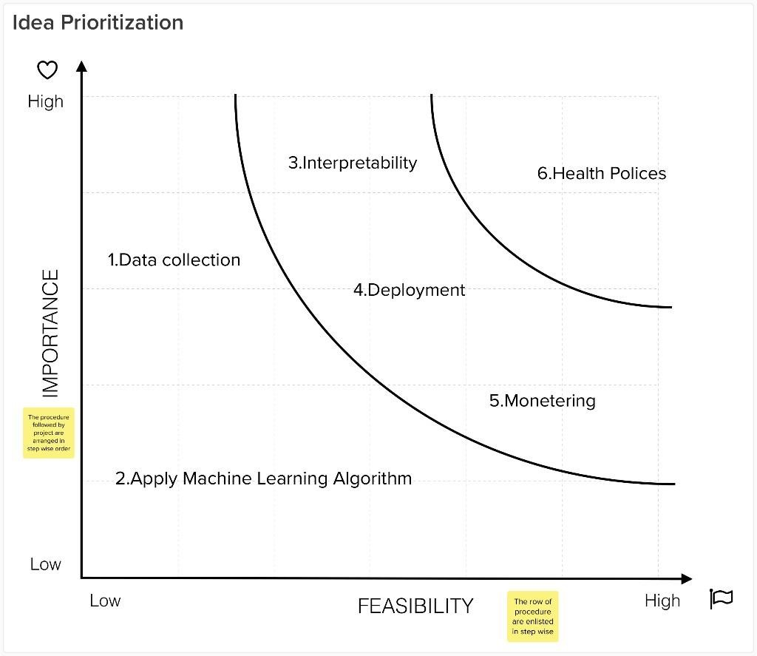

#### Proposed Solution

The proposed solution for the above project is to develop an accurate and efficient breast cancer detection system using deep learning methods. The solution involves training deep learning models on a diverse dataset of breast images, including mammograms, ultrasound scans, and MRIs. These models will leverage advanced convolutional neural networks (CNNs) and transfer learning techniques to extract meaningful features from the images.

**Proposed Solution Template:**

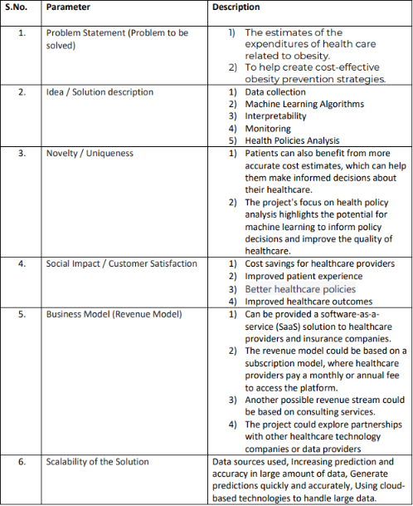

## REQUIREMENT ANALYSIS

#### Functional Requirements

#### 

#### Non-Functional Requirements

#### 

## PROJECT DESIGN

#### Data Flow Diagrams

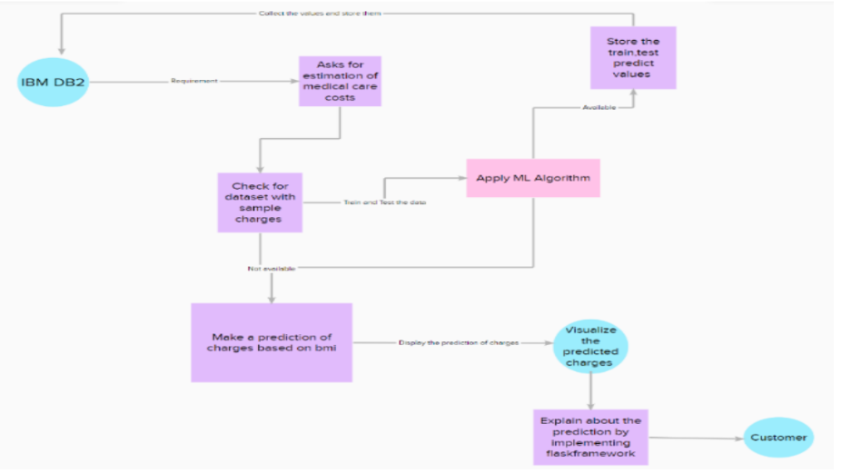

* 1. **Solution and Technical Architecture**

The solution architecture for estimation and cost prediction in health care system, medical bodies and organization enhancement to reduce obesity by cost awareness.

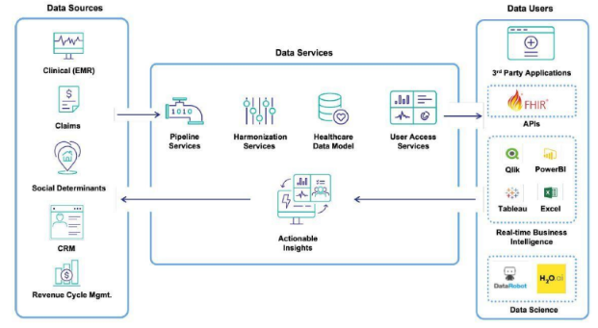

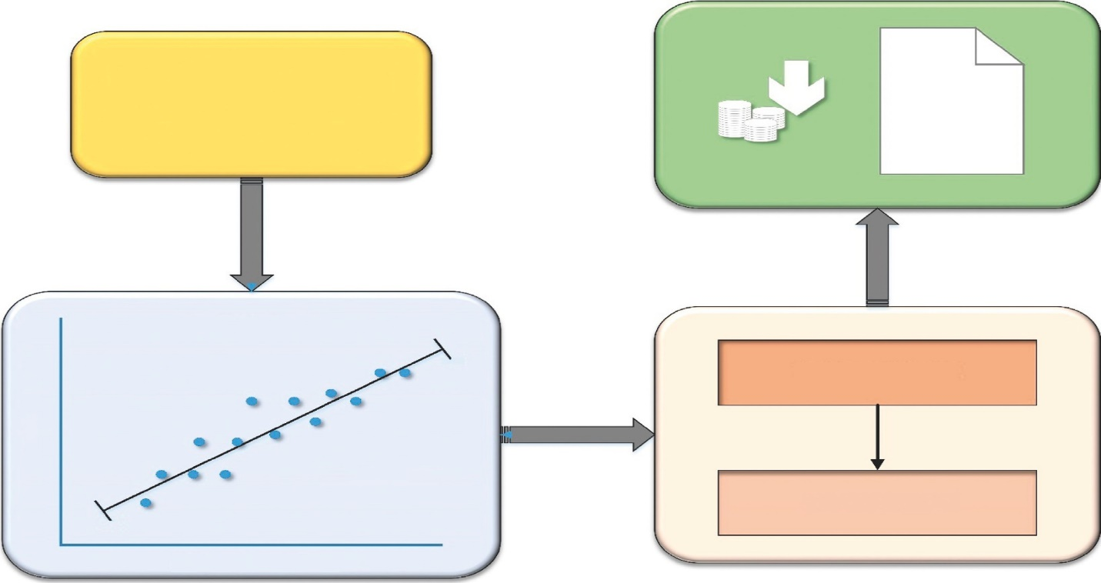

Continuous Valued Input (Data collection)

Estimated healthcare Costs of the patients’

Lincar Rcgrcssion

3/28

Trained Model

Y = bX + A + ϵ

Tested Model

9/27

Independent variables

* 1. **User Stories**

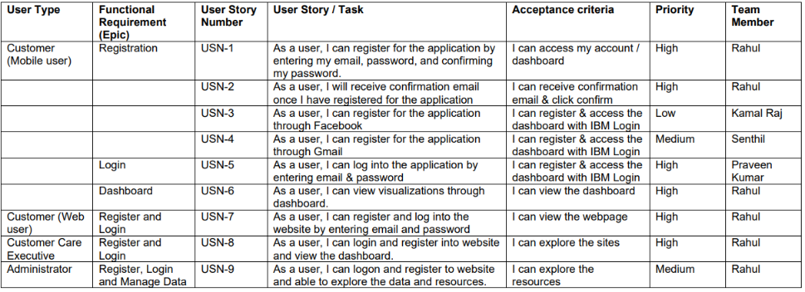

* 1. **Feature 1**

## CODING & SOLUTIONING

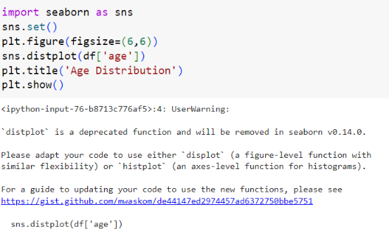

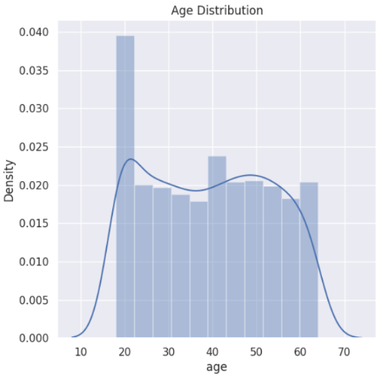

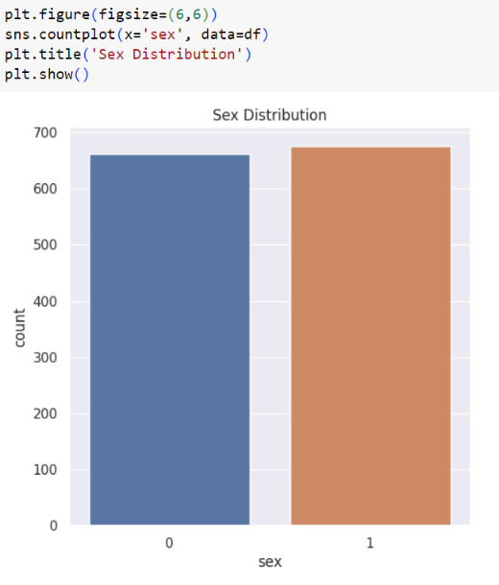

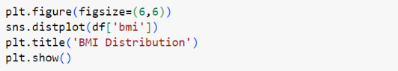

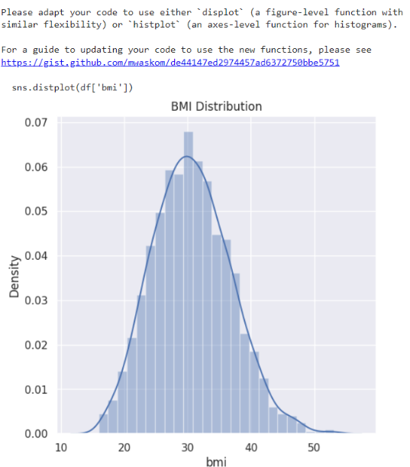

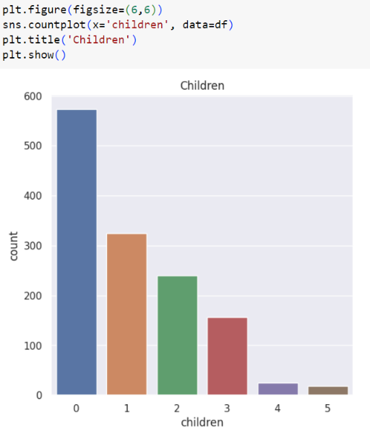

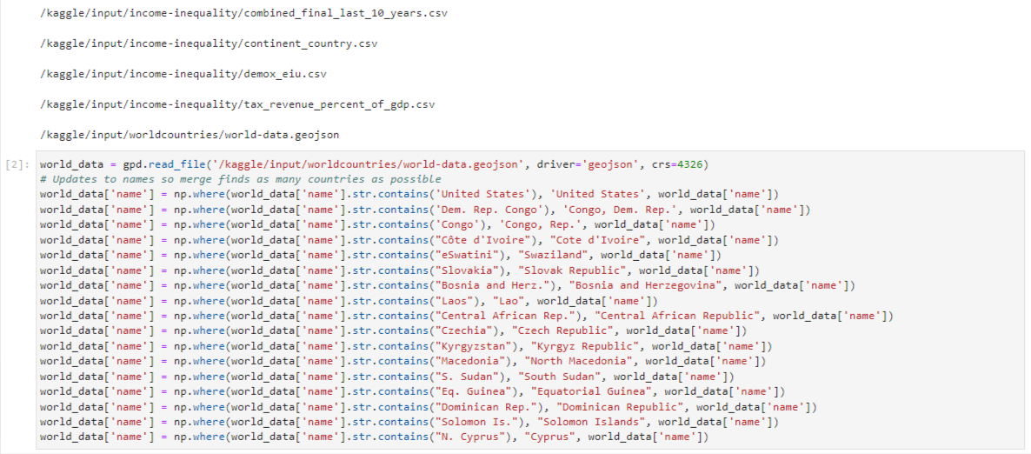

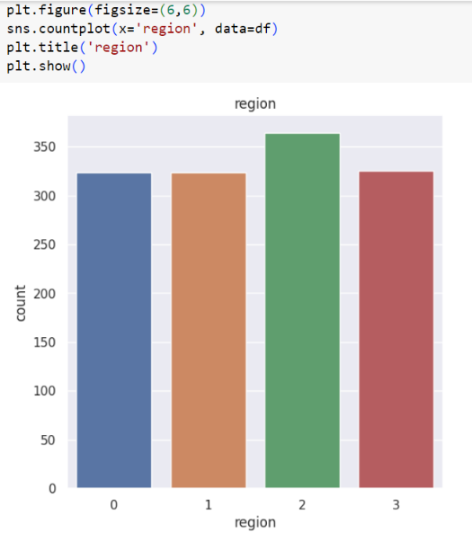

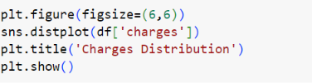

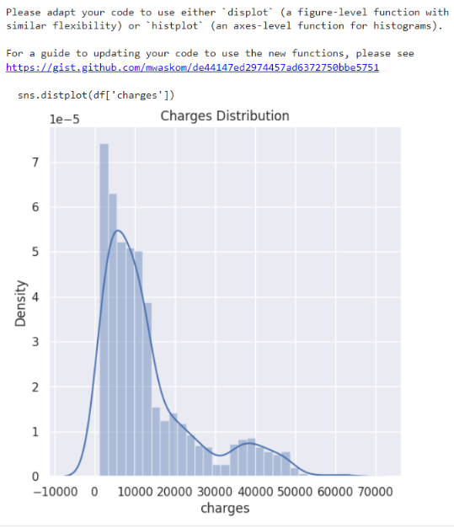

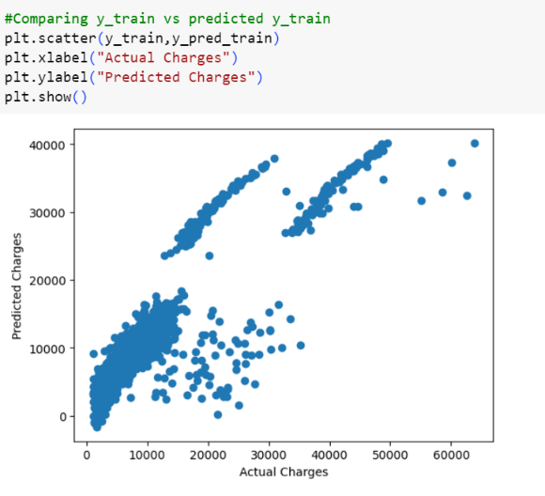

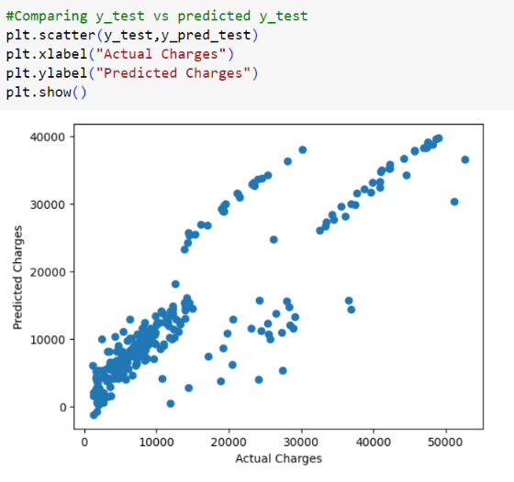

#### Feature 2

#### 

#### 

#### 

#### 

#### 

## RESULTS

#### Performance Metrics

* **Accuracy:** Measure the accuracy of the cost estimation and prediction models by comparing the predicted costs to the actual costs, providing a measure of how well the models perform.
* **Precision:** Assess the precision of the models in correctly identifying high-cost cases, minimizing false positives and ensuring accurate cost predictions for specific medical conditions or procedures.
* **Recall:** Measure the ability of the models to correctly identify high-cost cases, minimizing false negatives and capturing all relevant instances of high-cost hospitalizations or medical care.
* **Mean Absolute Error (MAE):** Calculate the average absolute difference between the predicted costs and the actual costs, providing an overall measure of the model's predictive accuracy.
* **Root Mean Square Error (RMSE):** Determine the square root of the average squared differences between the predicted costs and the actual costs, offering a measure of the model's predictive precision.
* **R-squared (R²):** Assess the proportion of the variance in the cost data that can be explained by the predictive models, indicating how well the models fit the data.
* **Sensitivity:** Measure the proportion of true high-cost cases correctly identified by the models, indicating the models' ability to capture cases requiring significant financial resources.
* **Specificity:** Measure the proportion of true low-cost cases correctly identified by the models, ensuring accurate identification of cases with lower financial implications.

## ADVANTAGES & DISADVANTAGES

#### Advantages:

#### Accurate cost estimation for informed decision-making.

#### Optimized resource allocation and financial planning.

#### Fair pricing strategies and coverage plans for insurance companies.

#### Evidence-based policy decisions for efficient healthcare systems.

#### Enhanced affordability and accessibility of healthcare services.

#### Improved patient care delivery through optimized resource allocation.

#### Efficient utilization of healthcare resources and reduced waste.

#### Fair and transparent pricing for healthcare services.

#### Financial stability for healthcare providers and insurers.

#### Continuous improvement through data-driven analytics and machine learning.

#### Disadvantages:

### Data limitations may hinder accuracy.

### Lack of generalizability to diverse healthcare settings and populations.

### Incomplete capture of complex cost determinants.

### Models may become outdated due to changing healthcare landscape.

### Ethical considerations regarding patient privacy and data security.

### Limited interpretability of complex machine learning algorithms.

### Inherent uncertainty in cost estimation and prediction.

### Implementation challenges in integrating models into existing healthcare systems.

### 8.CONCLUSION

We provided a new linear regression that can easily dem- onstrate the reasons for producing a certain forecast re- garding potential healthcare expenses, which is a useful capacity in the healthcare area. The linear regression algo- rithm is used to estimate the healthcare costs of the patients such as obesity (BMI) using certain devices such as smartphones and smart devices. For estimation, by the use of linear regression, supervised learning performs more ac- curately. By providing comprehensive evidence, regression methodology can be eﬀectively used for prognosis in con- junction with the dataset. The domain and time accuracy will determine the prediction model and the estimation of healthcare expenses. The proposed method reduces the risk of overﬁtting, and also, training time is less. This method is eﬀective in estimating the healthcare costs of patients with an accuracy rate of 97.89%. The extensive tests on a real-time world database have conﬁrmed the eﬃciency of our method.

the above project on the estimation and prediction of hospitalization and medical care costs holds significant promise in improving healthcare economics and decision-making. By leveraging advanced data analytics techniques and machine learning algorithms, the project aims to provide accurate cost estimation, optimize resource allocation, and promote affordability and accessibility of healthcare services.However, it is essential to acknowledge the potential limitations and challenges associated with the project. Data limitations, including quality and availability, may impact the accuracy and generalizability of the models. The complex nature of cost determinants and the evolving healthcare landscape introduce uncertainties that may affect the long-term viability of the developed models. Additionally, ethical considerations related to patient privacy and data security must be addressed throughout the project to ensure responsible data handling.

Despite these challenges, the project's advantages are substantial. Accurate cost estimation facilitates informed decision-making, enabling healthcare providers to optimize their financial resources and improve patient care delivery. Insurance companies can develop fair pricing strategies, enhancing financial planning and ensuring equitable coverage for policyholders. Policymakers can make evidence-based decisions, leading to efficient resource allocation and effective healthcare policies. Overall, the project's outcomes can contribute to enhancing healthcare management, affordability, and the delivery of high-quality care. Continuous improvement and ongoing adaptation to emerging trends will be crucial for the long-term success and impact of the project.

## 9 FUTURE SCOPE

* **Incorporating Real-Time Data:** The project can be expanded to integrate real-time data sources, such as wearable devices and remote patient monitoring, to capture up-to-date information on patient health and healthcare utilization, enabling more accurate and timely cost predictions.
* **Integration of External Factors:** Future iterations of the project can consider incorporating external factors like socioeconomic conditions, environmental factors, and public health indicators to enhance the predictive models and provide a more comprehensive understanding of cost drivers.
* **Predictive Analytics for Cost Management:** The project's framework can be extended to develop predictive analytics models that not only estimate costs but also proactively identify potential cost-saving opportunities, enabling proactive cost management strategies and interventions.
* **Comparative Analysis and Benchmarking:** The project can explore the use of comparative analysis and benchmarking techniques to compare costs across different healthcare providers, regions, or treatment approaches, enabling performance evaluation and identifying areas for improvement.
* **Long-Term Cost Prediction:** Building on historical data, the project can explore methods to predict long-term costs for chronic diseases or ongoing treatment plans, helping healthcare organizations and policymakers plan for future resource allocation and budgeting.
* **Incorporating Patient Outcomes:** Future iterations of the project can integrate patient outcome measures, such as readmission rates, treatment effectiveness, and patient satisfaction, into the cost estimation models to assess the value and efficiency of different healthcare interventions.
* **Decision Support System:** The project can evolve into a decision support system that not only provides cost estimates but also offers recommendations and insights to guide healthcare providers, insurers, and policymakers in making informed decisions related to cost-effective care delivery and resource allocation.

### 10. APPENDIX

### 

### 

### 

### 

### Healthcare Data Visualization Development | Tateeda Global

